**INTI International College Penang School of Engineering and Technology**

**3+0 Bachelor of Science (Hons) in Computer Science, in collaboration with Coventry University, UK**

**3+0 Bachelor of Science (Hons) in Computing, in collaboration with Coventry University, UK**

**Coursework cover sheet**

**Section A - To be completed by the student**

|  |  |
| --- | --- |
| Full Name: **ARSYAD HASSAN BIN SEGU HASAN GANI** | |
| CU Student ID Number: **P22014749** | |
| Semester: **1** | |
| Session:  **August 2022** | |
| Lecturer:  **Nadhrah Abdul Hadi (nadhrah.abdulhadi@newinti.edu.my)** | |
| Module Code and Title:  **4067CEM Software Design** | |
| Assignment No. / Title:  **Continuous Assessment** | % of Module Mark:  **50** |
| Hand out Date:  **6th September 2022** | Due Date:  **Task 1: 30 September 2022, by 11.59pm.**  **Task 2: 18 November 2022, by 11.59pm**  **Task 3: 4 November 2022, by 11.59pm.**  **Task 4: 4 November 2022, by 11.59pm.**  **Task 5: 4 November 2022, by 11.59pm.** |
| Penalties: No late work will be accepted. If you are unable to submit coursework on time due to extenuating circumstances, you may be eligible for an extension. Please consult the lecturer. | |
| Declaration: I/we the undersigned confirm that I/we have read and agree to abide by the University regulations on plagiarism and cheating and Faculty coursework policies and procedures. I/we confirm that this piece of work is my/our own. I/we consent to appropriate storage of our work for plagiarism checking.  Signature(s): __________**ARSYAD___**___________ | |

**Section B - To be completed by the module leader**

|  |  |  |
| --- | --- | --- |
| Intended learning outcomes assessed by this work:  1. Understand and apply appropriate concepts, tools and techniques to each stage of the software development  2. Understand and apply design patterns to software components in developing new software  3. Demonstrate an understanding of project planning and working to agreed deadlines, along with professional, interpersonal skills and effective communication required for software production  5. Demonstrate an awareness of, and ability to apply, social, professional, legal and ethical standards as documented in relevant laws and professional codes of conduct such as that of the Malaysian National Computer Confederation. | | |
| Marking scheme | Max | Mark |
| 1. User Story Mapping 2. Setting up a GitHub Repository 3. Creating a Class diagram and design pattern selection 4. Creating a Prototype User Interface and Usability Testing 5. Discuss the ethical issue related to the software | 20  10  30  20  20 |  |
| Total | 100 |  |

# Task 4 – Creating a Prototype User Interface and Usability Testing (20 marks)

Create a Prototype User Interface (hand drawn/digital) of TWO (2) important functions of the proposed system. Come up with a usability testing questions. You don’t have to carry out the test, just prepare the questions. You should indicate what you are testing for in the Usability Testing.

Output – A Prototype and Usability Testing Questions. In Word format, uploaded to GitHub.

**TWO Main functions of Student Buddy System**

1. **Promotion Coupon in Homepage**

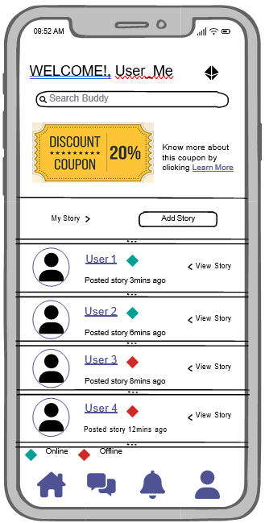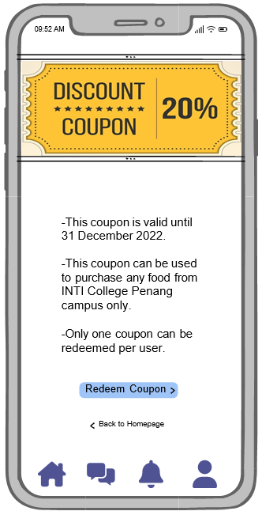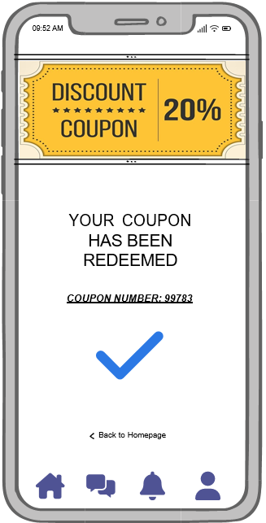

Figure 1 Homepage Figure 2 Coupon Details Figure 3 Coupon Redeemed

The first main function of this Student Buddy System is the users of this application are given a chance to redeem a coupon. It will be very useful for them as many students are facing financial issues. Therefore, this system provides the feature that students can easily redeem the coupon after they have made an account in this application. This coupon redemption button can be found in the homepage itself after logging in as shown in the Figure 1. Users can click the coupon image or the “Learn More” button to read the details of the coupon. After clicking either one of it, it will redirect to the coupon details page as shown in Figure 2. After reading all the details, users can click “Redeem Coupon” and it will redirect to the last page as shown in Figure 3 where students will get to see their coupon number and take note of it. Finally, students can show the number to the college’s canteen and use their coupon to get discount before the coupon expired.

1. **Sharing location to other users**

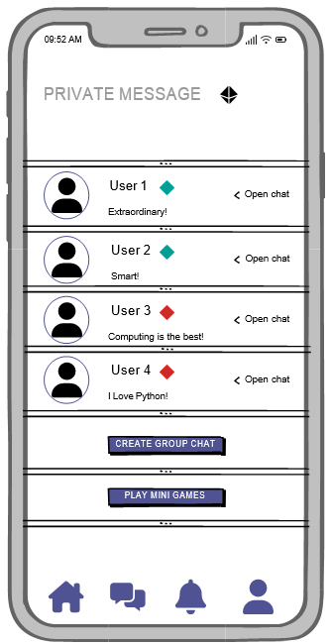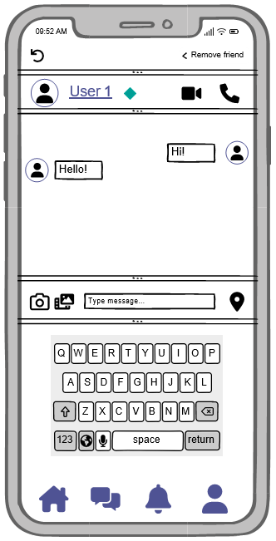

Figure 4 Private Message Figure 5 User 1 Chat

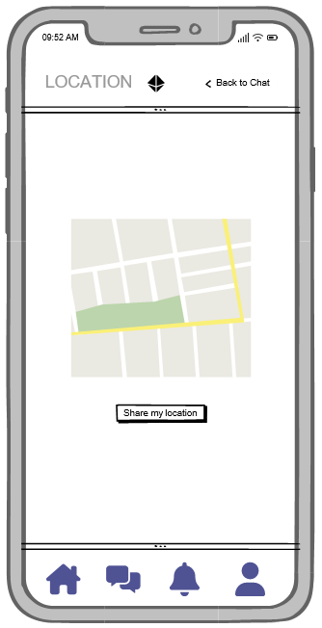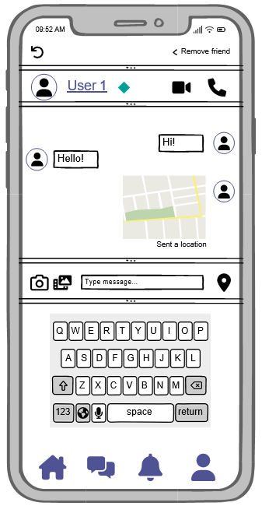

Figure 6 Share Location Figure 7 Location Shared



Figure 8 Location Icon

The second main function of this Student Buddy System is users can share location to other users. In this world of technology, location is one of the main things in everyone’s life. Almost every single day location will be used by people either for booking taxi or sharing any place for lunch and many more. Therefore, this feature called sharing location is developed in this application for the convenient of the users if they want to share their location to their friends. This feature can be used by clicking the private message icon on the below and it will redirect into the private message page as shown in Figure 4. Then, user can choose who they want to share their location with by clicking “open chat”. Then it will open that particular chosen user’s chat as shown in Figure 5. Moreover, user can click the location icon as shown in the Figure 8. After clicking, it will redirect the user to share location page as shown in Figure 6. By one click on the “ Share Location” button, the location of the user will be shared to that particular chosen user. Finally, as you can see in the Figure 7, the location is now shared and that is all. This feature is very user friendly and convenient for users to share their location to the friend.

**Usability Testing Questions**

1. How frequently, if at all, would you use this application?
2. How would you improve this application?
3. What would make you want to use this application?
4. Have you used system that is similar like this? If yes, state the reason.
5. What would make you not want to use this application?
6. What are your initial thoughts on this concept?
7. What was your overall impression on this application?
8. Is there any feature that is unnecessary in this application? If yes, state the reason.
9. On the scale of 1 to 10, how much will you rate on this developed application?
10. Do you think the mini game that is included is a good concept in this application?
11. Would you recommend your friends to use this application?
12. What is the feature that you think that is the best feature in this application?
13. Does this application fulfil your expectations?
14. What important features are we missing?
15. What are you trying to solve by using this application?